**Safety And Living Conditions of Pourakarmikas**

Sanitation workers, or “Pourakarmikas” form the last mile of Sanitation facilities provided by the Urban Local Bodies (ULBs) in Karnataka. They are at the frontline of keeping our cities clean, habitable, and pleasant. However, they are also subject to harrowing work conditions and are often perceived as doing indignified work. The social stigma working against sanitation workers has grown along with lack of investment in their well-being and work conditions.

Most face health issues, as seen in Table 1, most of which would be solved with simple personal protective equipment. There have been empty platitudes of providing safety gear and gloves, yet most collect waste with bare hands. The working conditions are inhumane, without access to clean drinking water, changing rooms, or washrooms. In addition to the stigma and indignity associated with sanitation workers, there is the additional burden of caste discrimination – about three-fourths of the Pourakarmikas are Dalits, along with garbage collection loaders and unloaders. These issues, while appearing to be individual failures of the ULBs belie a deeper systemic issue – the casualisation of work.

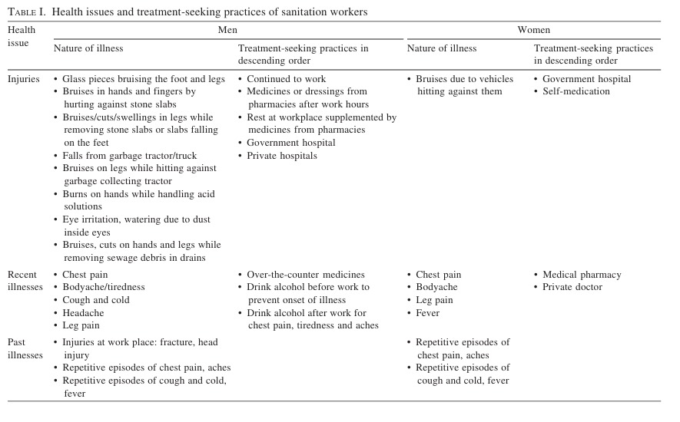Note: Table from Rangamani, Sukanya & Obalesha, Kannamedi & Gaitonde, Rakhal. (2015). Health issues of sanitation workers in a town in Karnataka: Findings from a lay health-monitoring study. The National medical journal of India. 28. 70-73.

Participatory Research in Asia note that sanitation workers are employed under three types of work contracts – permanent employees of the municipal corporation, contractual employees of the municipal corporation and outsourced workers. Permanent workers earn the highest wages, with the option of availing multiple benefits such as earned leaves, medical benefits, pension contributions and Provident Fund. Municipal contractual workers earn approximately one-half to one-fourth of a permanent worker’s salary, for the same job. Outsourced workers earn the lowest wages, often less than 1/4 of a permanent worker’s salary. Contractual and outsourced workers enjoy no benefits. Waste pickers, contractual and outsourced workers are not covered under social security and medical insurance schemes. Thus, there is a dire need to initiate policy formulation for their social and economic upliftment.

The Karnataka state government has initiated efforts to provide proper housing for Pourakarmikas. For instance, in Belagavi, 48 houses have already been built, and work on 158 more houses is underway. However, the number of Pourakarmikas with proper housing remains

limited, and many still face difficult living conditions. 5,188 houses for civic workers under 'Pourakarmika Gruha Bhagya Yojane' in Karnataka are promised but there is sparse information about how many of them benefited from this scheme.

As a result of the sustained struggle of contract Pourakarmikas, in June 2017, the Karnataka Government took a cabinet decision mandating the abolition of contractors and direct wages to workers. Despite this decision, the BBMP has been dragging its feet to implement it and the contract Pourakarmikas are suffering at the hands of the contractors daily.

The continuance of the illegal contract system results in a system wherein workers are exploited, not paid wages for months on end and made to work 365 days a year. The extent of abuse reached a crescendo when a contractor was alleged to have sexually harassed Pourakarmikas when they asked for their wages in 2017.

**Proposed Solutions:**

Urban and semi-urban waste management plans must include all sanitation workers involved in waste collection, transport, and processing. Policies should ensure safe and hygienic waste handling, with municipalities providing high-quality safety gear to all workers, regardless of demand. Community involvement is key to upholding workers' dignity.

A fair wage structure must be established, recognizing the similarity in work across all sanitation workers and reducing unacceptable wage gaps. Contract workers, who lack benefits despite equal work hours, are especially vulnerable. Immediate steps must be taken to issue payslips and wage books to all workers, with surprise checks on clerks to ensure compliance.

Local leaders should regularly confer with sanitation workers to ensure their rights and entitlements. Incompetent leadership should be scrutinized by local governments. Independent workers' organisations should be encouraged to address wages, work conditions, and reduce

income inequality. SWaCH, the sanitation workers’ association from Pune can be an inspiration in this regard.

Adequate facilities such as first aid, drinking water, clean toilets, and low-cost sanitary vending machines should be provided, particularly for women workers. Maternity, paid, and medical leave must be enforced, with penalties for non-compliance by private employers. Automated vehicles should replace heavy carts, as many workers suffer from anaemia and musculoskeletal issues.

Daycare centres should be established to support working mothers. Internal Committees under the Sexual Harassment of Women at Workplace Act, 2013, must be set up in all municipalities to address harassment cases, ensuring independent, unbiased functioning.

Policies for sanitation workers should be evaluated by independent bodies from the Valmiki community, supported by civil society organizations, and local bodies must be held accountable for failures in policy implementation.

**ABOUT US**Make Parliament Great Again (#MPGA) is a citizen’s initiative that aims to raise public issues with representatives & decision makers from across the political spectrum with the objective of reclaiming the Parliament as the House of the People.